**Daily Scrum or Standup Meeting**

Team name: __Group10_______________________

Scrum Master: __Tanner Hooer_____________________

Date:_4-4-19______________________________

|  |  |  |  |
| --- | --- | --- | --- |
| **Team Member** | **What did you do since the last scrum?** | **What do you plan to do before the next scrum?** | **What obstacles do you have?** |
| George | Researched how to render requests | get the movie detail page done and move on to testing | never done testing before |
| Zach | Did some research on sending an email from python | Implement emailing in python and unit tests. | Email will be triggered from movie view info page which has yet to be completed. |
| Tanner | Started working on the unit test for the borrow model. | Going to finish unit test for borrow model. | Need to figure out how to mock a user for the borrow model test. |
| Nick | Watched for others pull requests | Create accept borrow request page. with ways to navigate to this page and also endpoint for submitting the users response. | some features depend on other work I might become partial stuck at some point. |
|  |  |  |  |

# Burndown

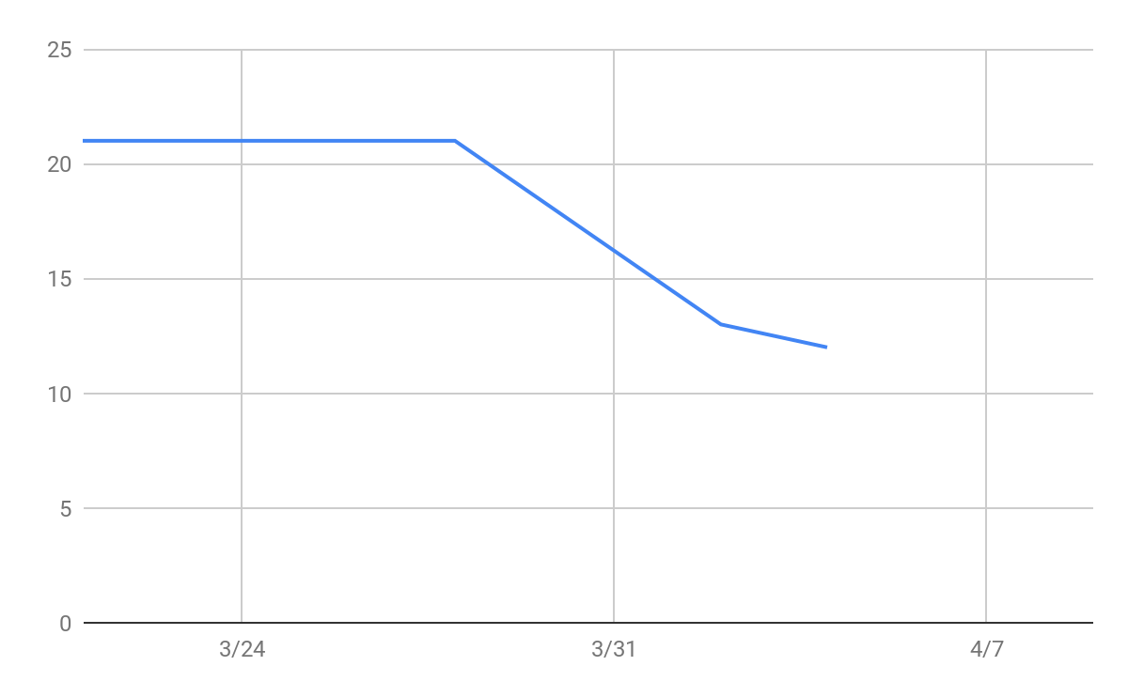

# Screenshot of you task board

